**­­NAAN MUDHALVAN PROJECT SUBMITTION**

**(SERVICE NOW)**

**TITLE: Optimizing User, Group, and Role Management with Access Control and Workflows**

**NM_ID: 9B19DFDA60F5004B3B8400C38B316F47**

**COLLEGE CODE : 0110,**

**COLLEGE : Dharmamurthi Rao Bahadur Calavala Cunnan Chetty's Hindu College,**

**Team members:**

**1.GOKUL . K**

**2. ILAMUGILAN . S**

**3.** **VIGNESHWARAN R**

**Projects Description:**

This projects is about building a clear and organized system for managing users, groups, and roles in a small project team. Right now, tasks and responsibilities are not clearly defined, which causes confusion about who should do what and how progress should be tracked.

**The project introduces:**

* **Users**: People who are part of the project (e.g., Alice and Bob).
* **Groups**: Teams or categories that users belong to.
* **Roles**: Specific responsibilities or permissions assigned to each user (e.g., Project Manager or Team Member).
* **Access Control**: Rules that decide who can view, edit, or manage tasks and project details.
* **Workflow**: A step-by-step process to assign, track, and complete tasks in an organized way.

For example, Alice (Project Manager) can assign tasks and track progress, while Bob (Team Member) can update his work and mark tasks as complete. This makes the process simple, transparent, and efficient for everyone.

By the end, the system will ensure accountability, smooth collaboration, and better project progress tracking.

### ****1. Users****

Users are the people who are part of the project.

* Example: Alice (Project Manager) and Bob (Team Member).  
  Each user has their own account to log in, see tasks, and update progress.

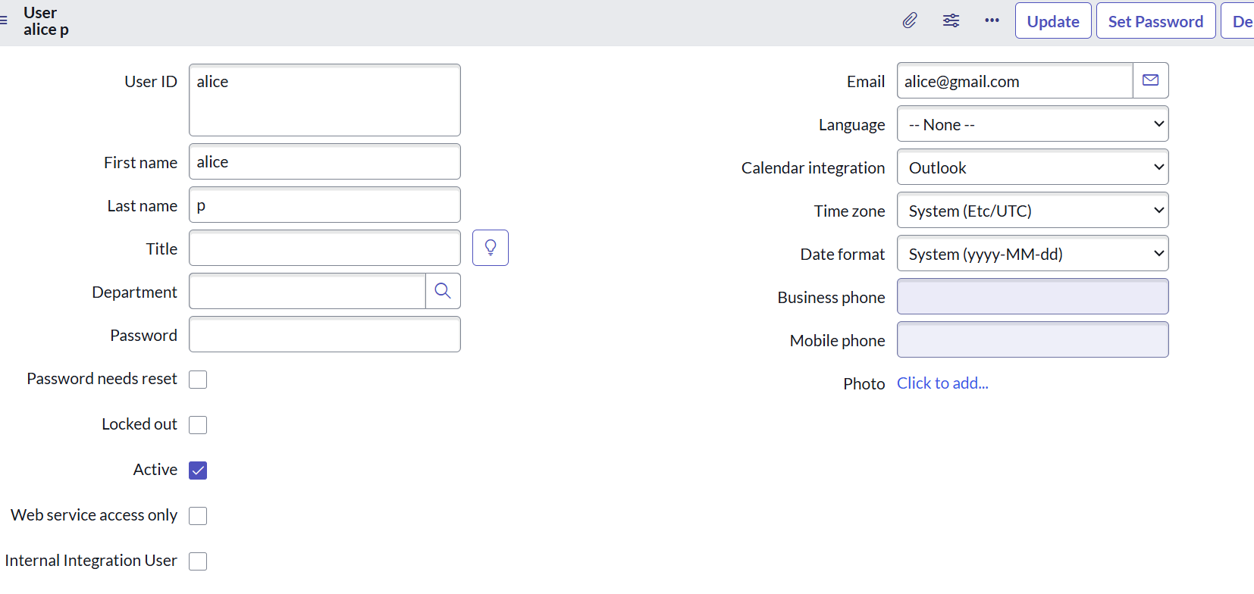

Other user:

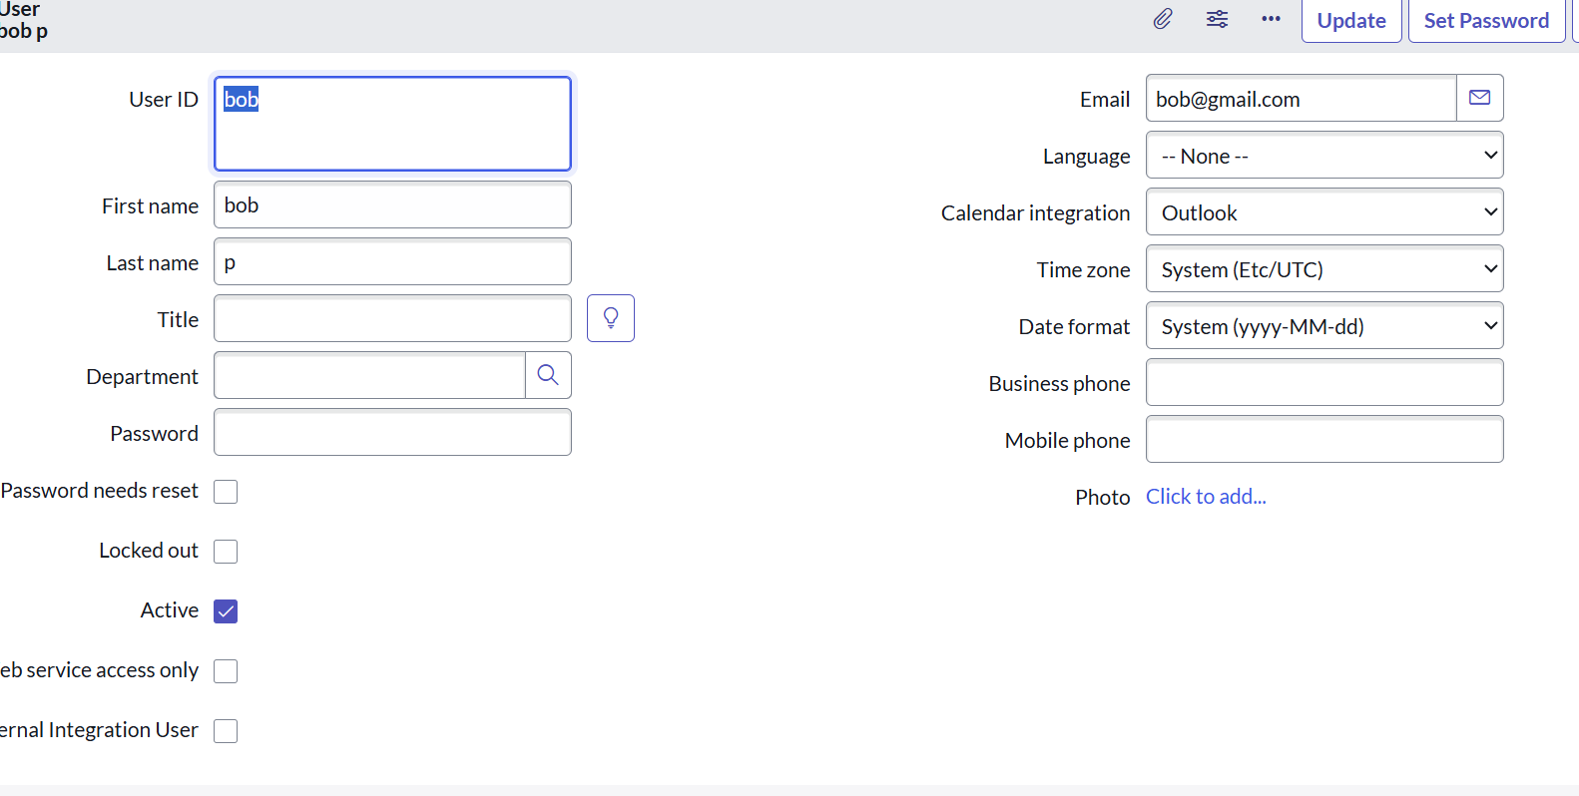

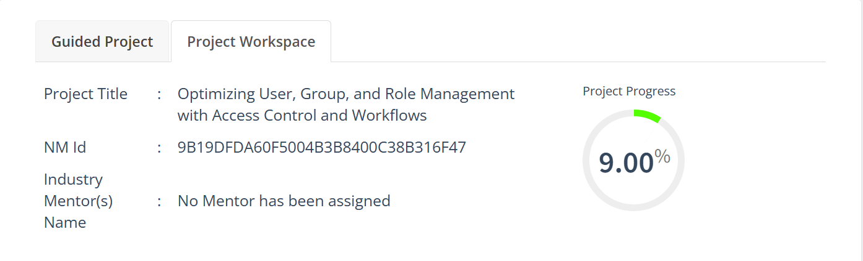

### 2. ****Create Groups****

* Open **ServiceNow**.
* In the left menu, click on **All** and search for **Groups**.
* Under **System Security**, select **Groups**.
* Click on **New** to create a new group.
* Fill in the required details for the group (e.g., Group Name, Description).
* Click **Submit** to save the group.

**Example Groups:**

* **Project Managers** – for people who manage tasks and track progress.
* **Team Members** – for people who work on assigned tasks.

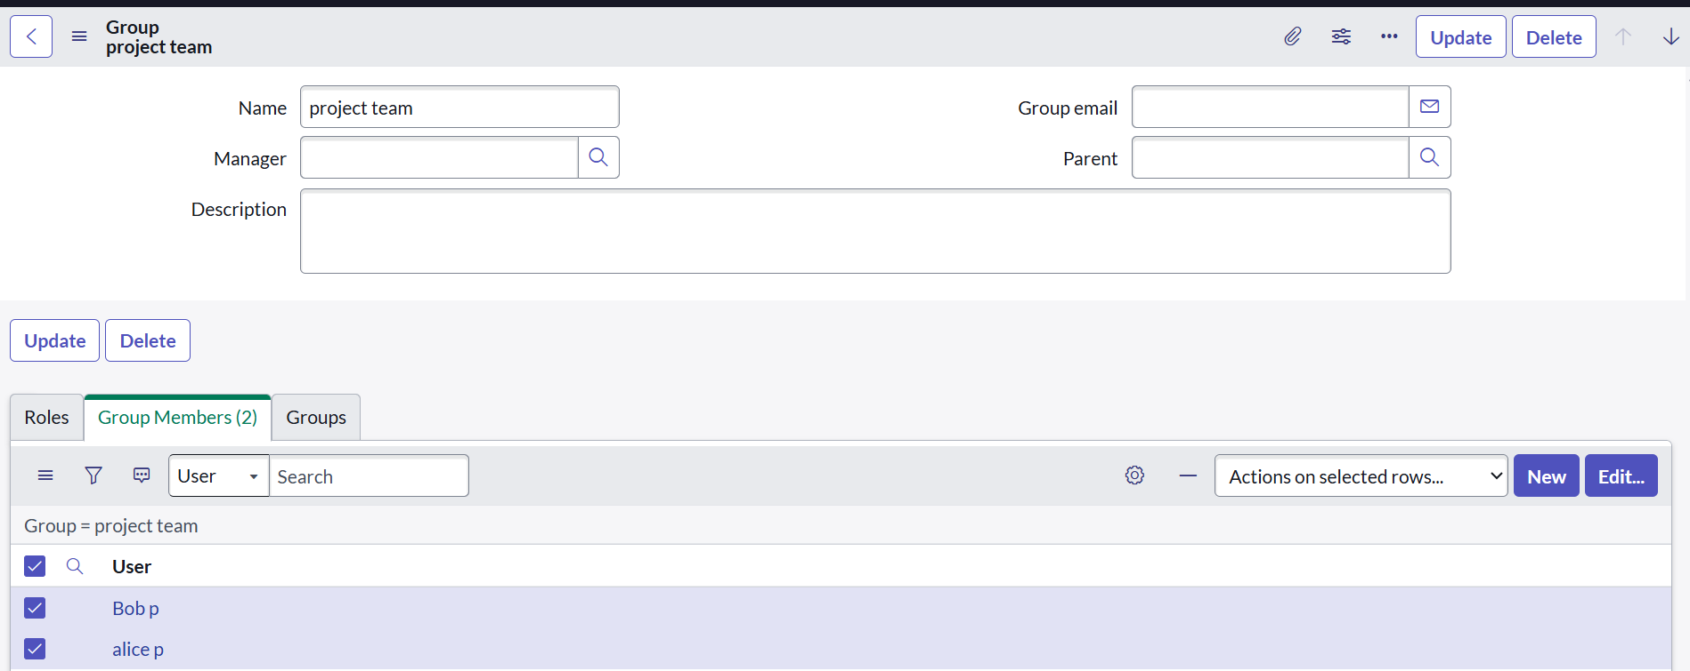

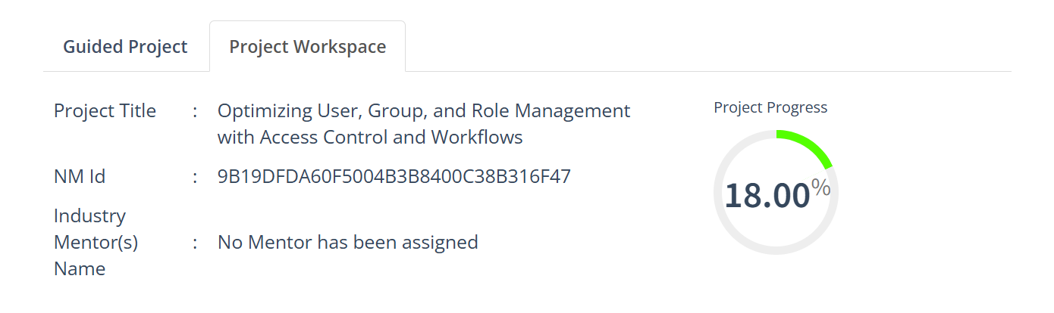

### ****3.Create Roles****

* Open **ServiceNow**.
* In the left menu, click on **All** and search for **Roles**.
* Under **System Security**, select **Roles**.
* Click on **New** to create a new role.
* Fill in the required details for the role (e.g., Role Name, Description).
* Click **Submit** to save the role.

**Example Roles:**

* **Project Manager Role** – can assign tasks, track progress, and manage the project.
* **Team Member Role** – can view assigned tasks, update status, and complete work.

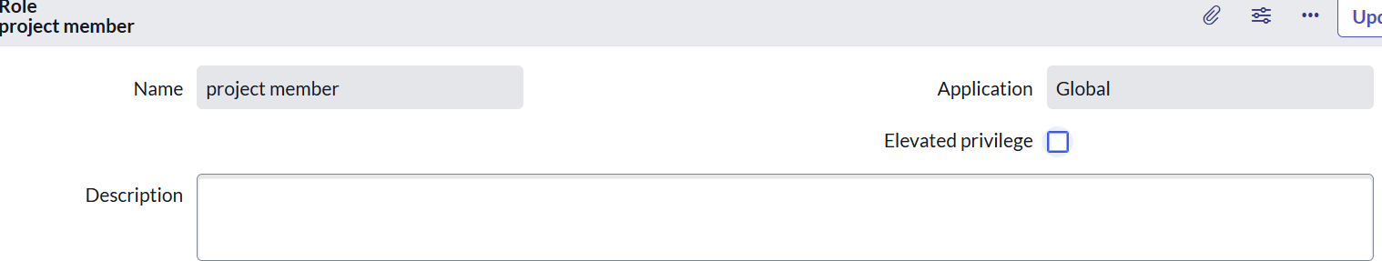

Other Role :

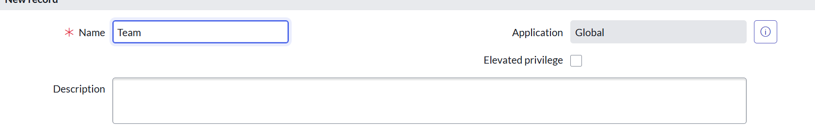

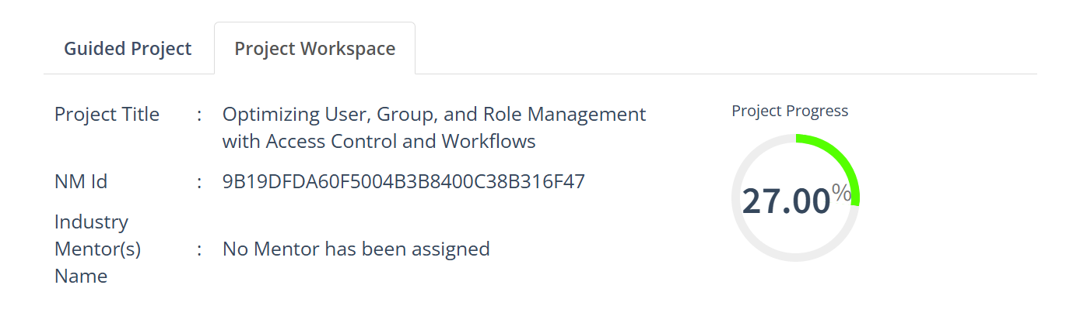

### ****4.Create Table****

* Open **ServiceNow**.
* In the left menu, click on **All** and search for **Tables**.
* Under **System Definition**, select **Tables**.
* Click on **New** to create a new table.
* Enter the required details for the table, such as:
  + **Label** (name of the table, e.g., Project Tasks)
  + **Name** (auto-generated based on the label)
  + **Application** (select the application where the table belongs)
* Add fields (columns) to store information, such as:
  + **Task Name**
  + **Assigned To**
  + **Status**
  + **Due Date**
* Click **Submit** to save the new table.

**Example Table:**

* **Table Name:** team members

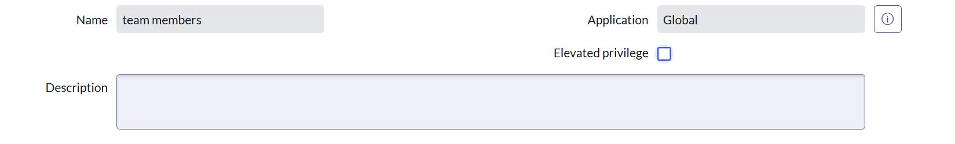

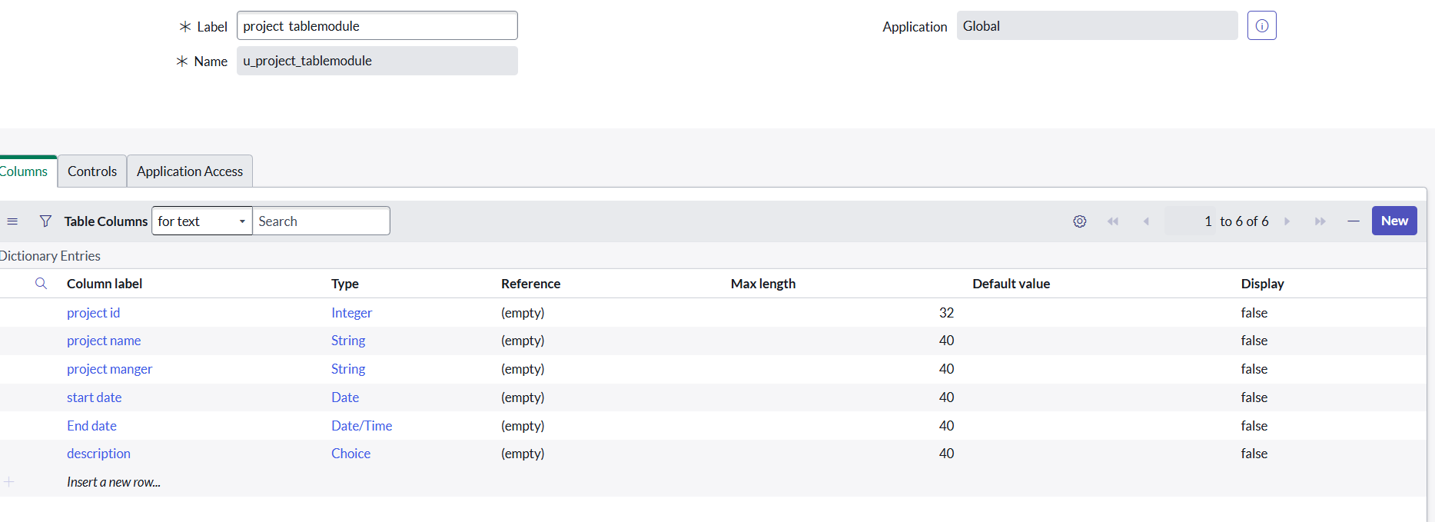

### 

### ****.5. Assign Users to Groups****

* Open **ServiceNow**.
* In the left menu, click on **All** and search for **Groups**.
* Under **System Security**, select **Groups**.
* Open the group where you want to add users.
* In the **Group Members** section, click **Edit**.
* Select the users you want to add to this group.
* Click the **Add →** button to move them into the group.
* Click **Save** or **Update** to confirm.

**Example Assignment:**

* Add **Alice** to the **Project Managers** group.
* Add **Bob** to the **Team Members** group.



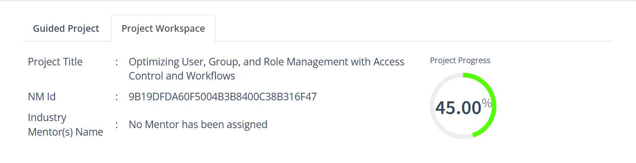

### 6. ****Assign Roles to Alice (Project Manager)****

* Open **ServiceNow**.
* In the left menu, click on **All** and search for **Users**.
* Under **System Security**, select **Users**.
* Find and open the record for **Alice**.
* Scroll down to the **Roles** tab.
* Click **Edit**.
* From the list of available roles, select **Project Manager Role**.
* Click the **Add →** button to move it into Alice’s assigned roles.
* Click **Save** or **Update** to confirm.

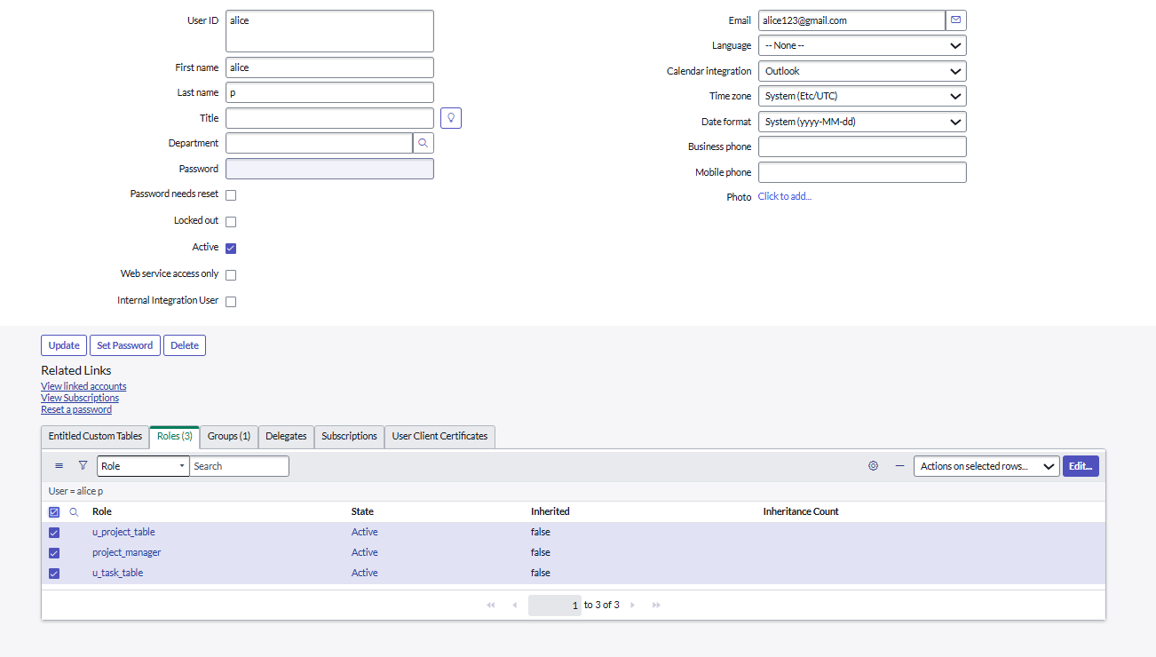

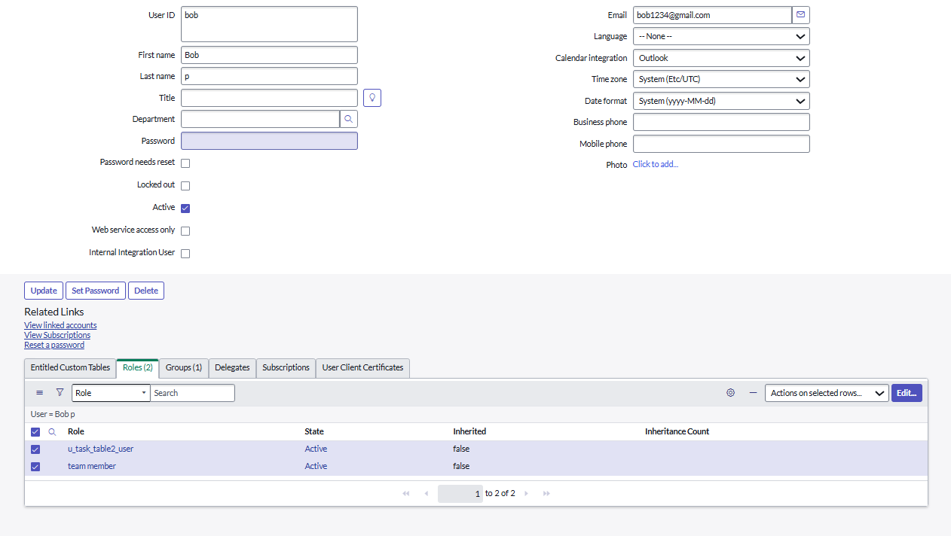

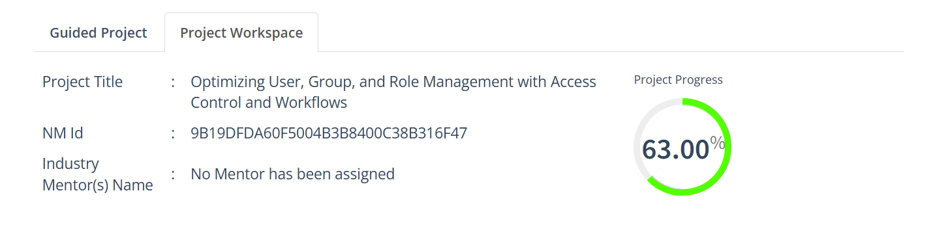

### ****7.Assign Table Access to Application****

* When you create a new table in ServiceNow, the system automatically creates an **Application** and a **Module** for that table.
* Open the **Application Navigator** and search for your project table application (e.g., Project Table).
* Click on **Edit Module**.
* Assign the **Project Member Role** to this application so only project members can access it.
* Next, search for **Task Table 2** in the Application Navigator.
* Click on **Edit Application**.
* Assign both the **Project Member Role** and the **Team Member Role** to this application.

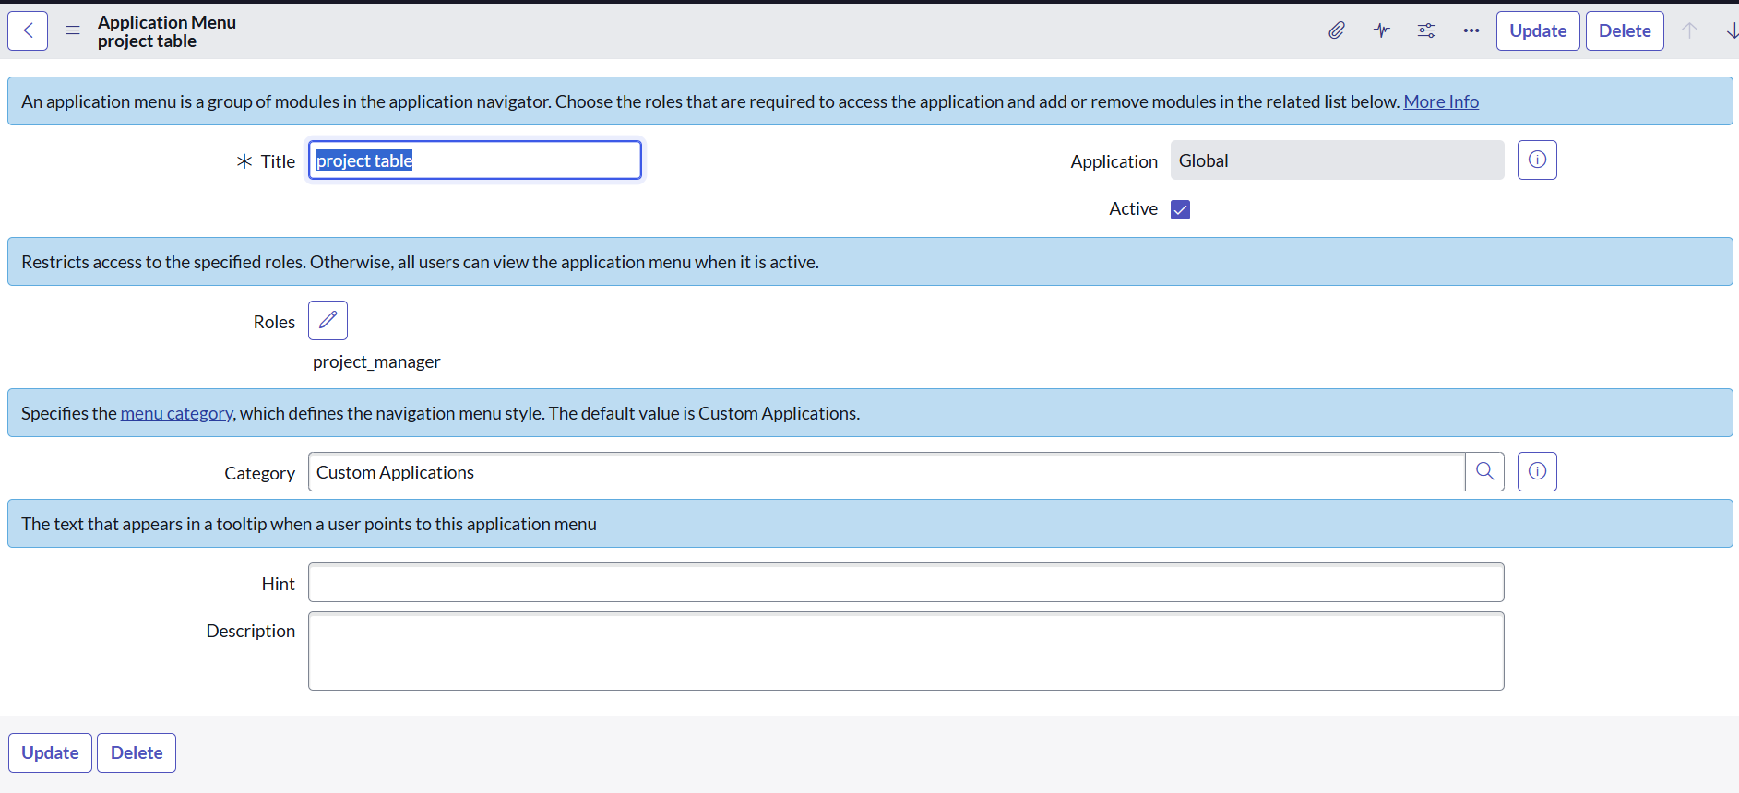

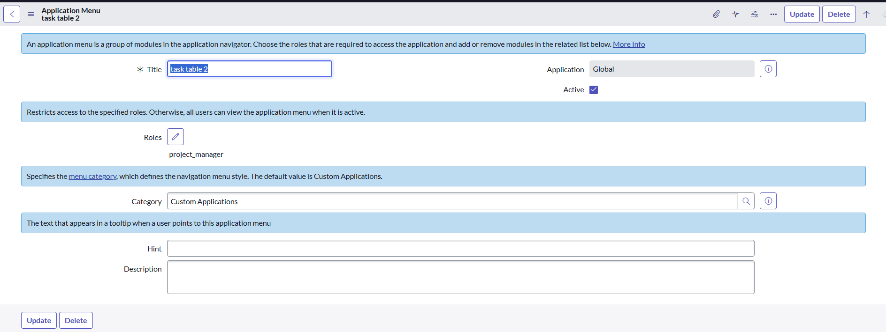

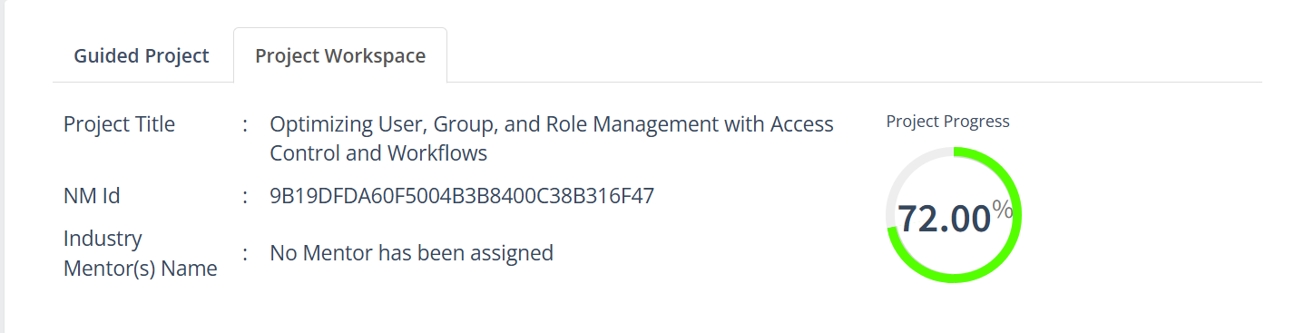

### ****8.Create ACL (Access Control List)****

* Open **ServiceNow**.
* In the left menu, click on **All** and search for **ACL**.
* Under **System Security**, select **Access Control (ACL)**.
* Click on **Elevate Role** (to get admin access for creating ACLs).
* Click on **New** to create a new ACL.
* Fill in the details for the ACL, such as:
  1. **Table/Field** (what you want to control access to)
  2. **Operation** (read, write, create, delete)
  3. **Roles** (who should have access)
* Click **Submit** to save the ACL.
* 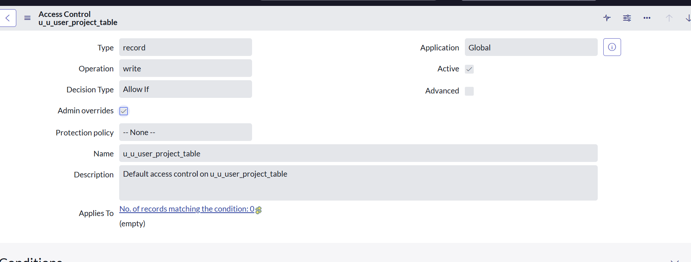

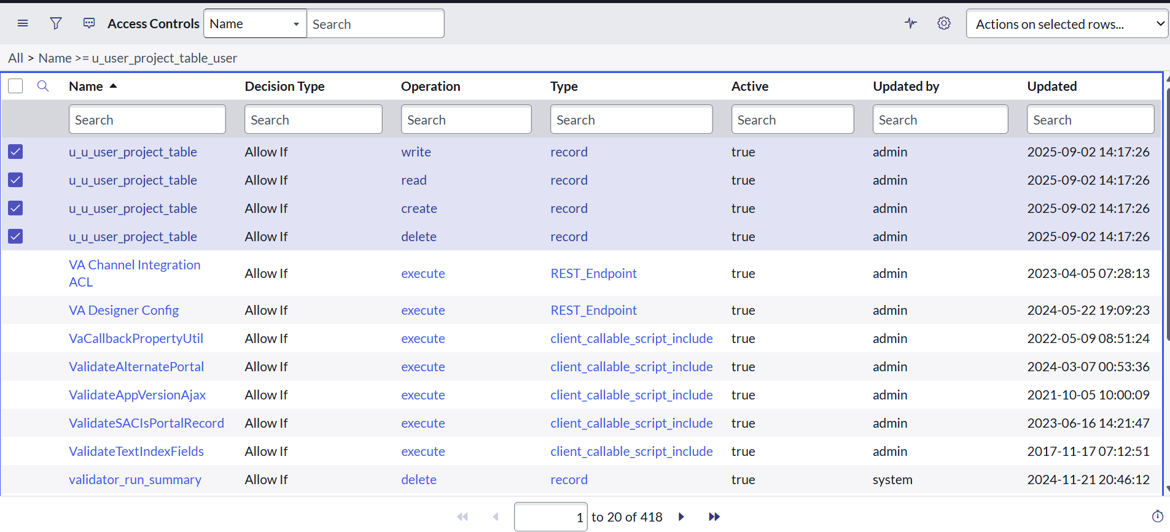

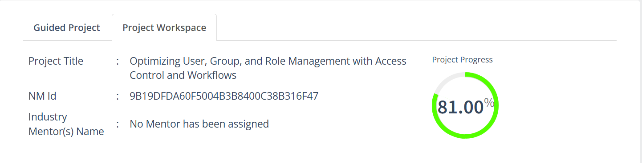

### 9. ****Create a Flow to Assign Operations Ticket to Group****

1. Open **ServiceNow**.
2. In the left menu, click on **All** and search for **Flow Designer**.
3. Open **Flow Designer** under **Process Automation**.
4. Click **New** → select **Flow**.
5. Fill in the flow details:
   * **Flow Name:** task table
   * **Application:** Global
6. Click **Build Flow**.

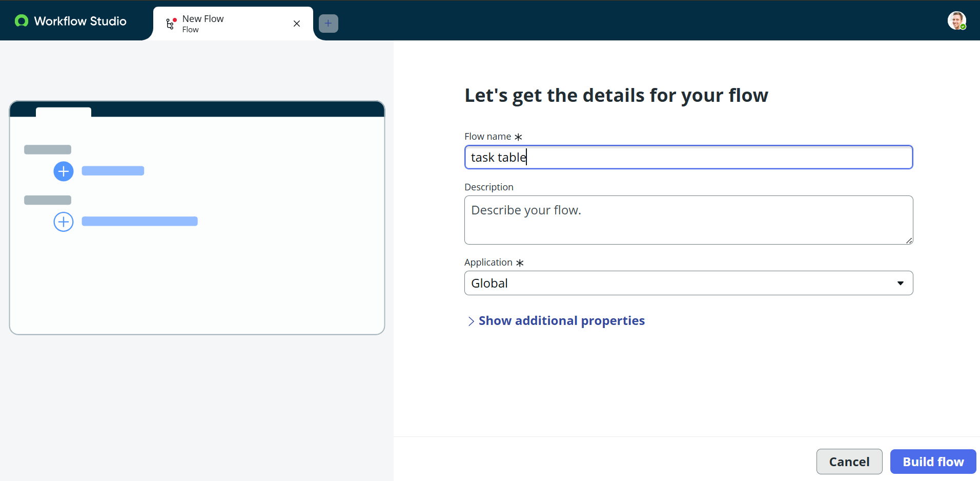

### ****Add a Trigger****

1. Click on **Add a Trigger**.
2. Search for **Create Record** and select it.
3. Choose **Table Name:** task table.
4. Add conditions:
   * **Status** → is → In Progress
   * **Comments** → is → Feedback
   * **Assigned To** → is → Bob
5. Click **Done**.

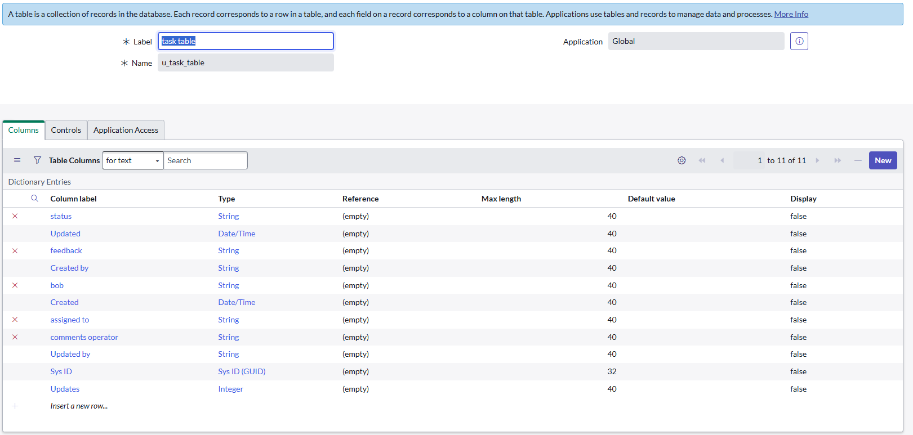

### ****Add Actions****

1. Click **Add an Action**.
2. Search for **Update Records**.
3. Drag fields from the **Data Pill** (right side) into the record field.
4. Table will auto-fill.
5. Add this field:
   * **Status = Completed**
6. Click **Done**.

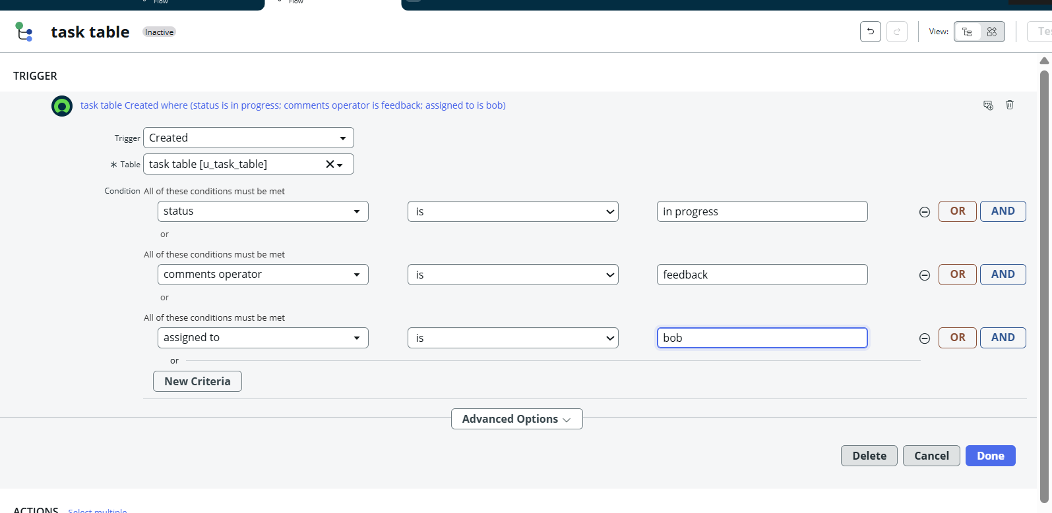

### ****Add Approval Step****

1. Under **Actions**, click **Add an Action**.
2. Search for **Ask for Approval**.
3. Drag the record fields from the **Data Pill**.
4. Table will auto-fill.
5. Fill details:
   * **Approval Field:** Status
   * **Approver:** Alice P
6. Click **Done**.

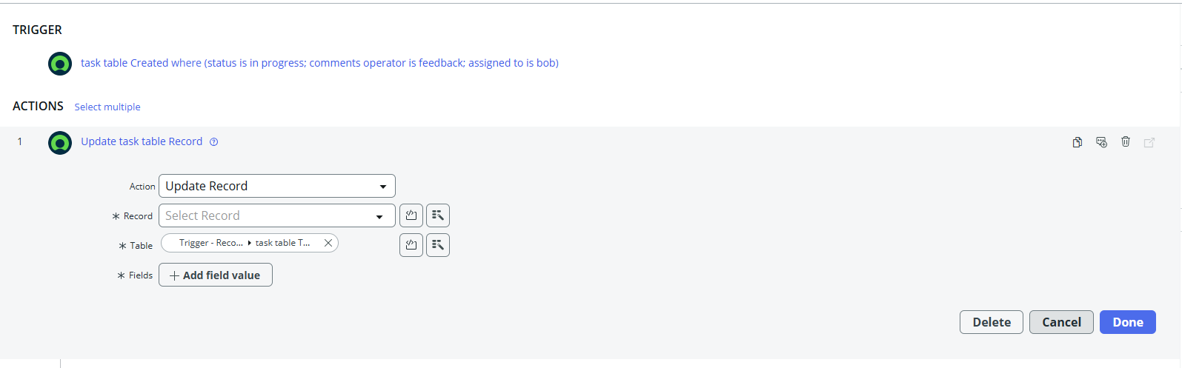

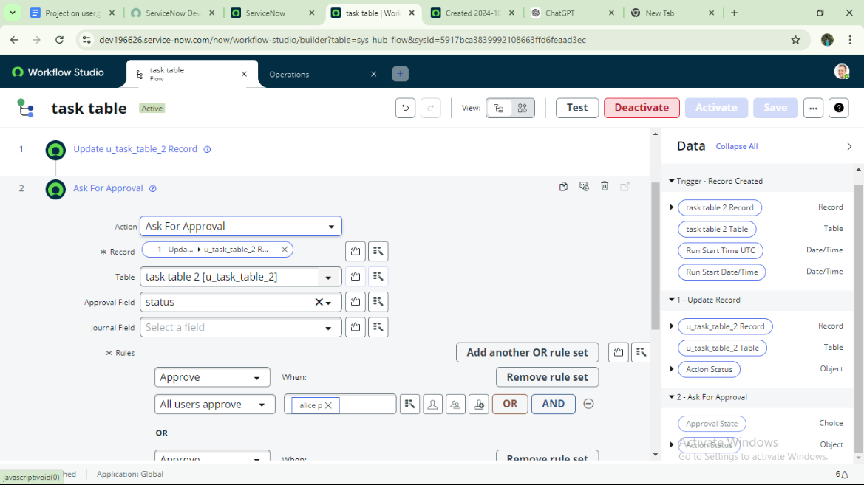

### ****Test the Flow****

1. In the **Application Navigator**, search for **Task Table**.
2. Check that the **Status** field updates to **Completed** when conditions match.
3. Then go to **My Approvals** under the **Service Desk**.
4. Alice P will see the approval request.
5. Right-click the request → select **Approve**.

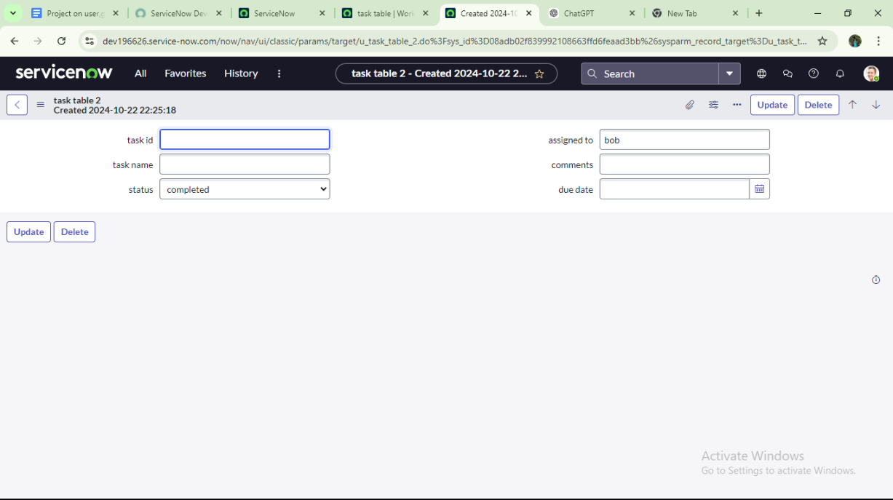

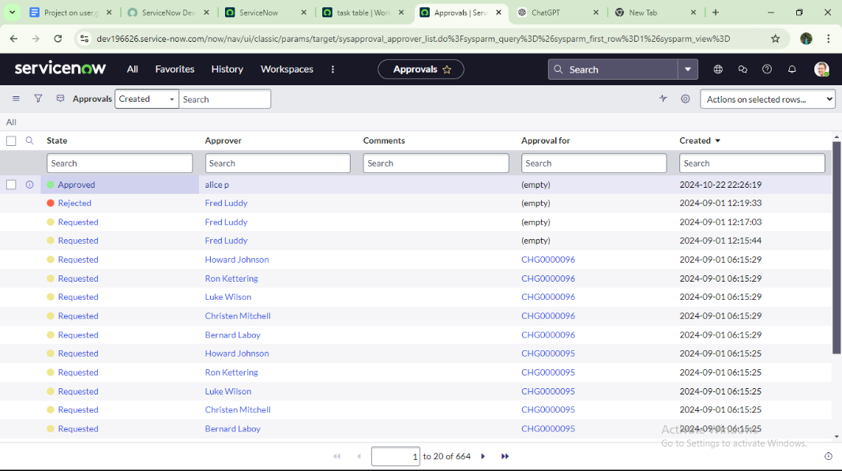

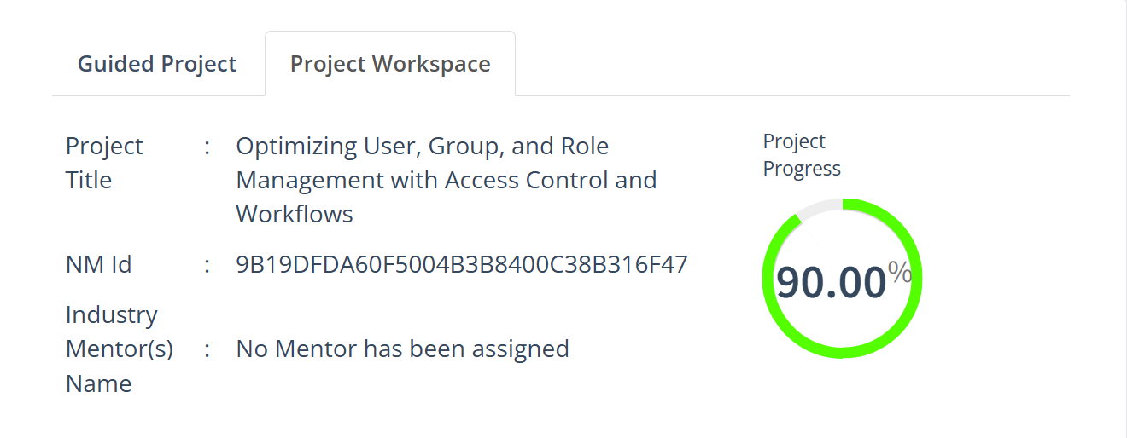

**Conclusion:**  
This scenario illustrates a systematic approach to project management by clearly defining the roles of Alice and Bob. Alice provides oversight, while Bob takes charge of execution, ensuring that responsibilities are balanced and collaboration remains effective. The inclusion of tables serves as a practical tool for organizing information, allowing projects, tasks, and progress updates to be tracked with ease. By fostering accountability and improving communication, this structured workflow ultimately drives projects toward successful completion.